Mininera & District Netball Association Inc.

1939-2026



Administration Guide

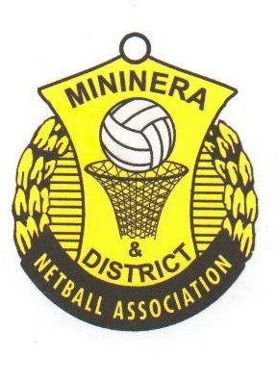MININERA & DISTRICT NETBALL ASSOCIATION
ADMINISTRATION GUIDE

CONTENTS

1. Cover Sheet
2. Contents Page
3. Meeting action sheet
4. Secretary Game day check list
5. Welcome
6. Affiliation
7. Netball Victoria Memberships
8. Co-Ordinators – Contacts
9-10. Injury Time and Rules
11. Injury Reporting
12. Injury Report Form
13. Grades and game times
14-15. Risk Management
16-18. Finals
19. Trophies
20. Representative Teams
21-22. Indemnity and Indemnity Consent Form
23-26. Role of Court Supervisors & Game Day Checklist
27-28. Executive Roles & Responsibilities Outline
29-31. Umpire Mentor Guidelines
32. Club Rotation Roster
33-34 Life Membership Criteria
35-36. Incident Reporting
37-38. Outdoor Facility Grading Sheet
39. Whistle Award
40. Netball Connect details
41. Executive Nomination Form
42-52. Codes of Conduct
53. Meeting Attendance List
54. Club Contacts template
55. Clearance Form

Appendices:
1. By-Laws
2. Constitution
MININERA & DISTRICT NETBALL ASSOCIATION

ACTIONS REQUIRED FROM MEETING

Date:

ACTION: | TO BE ACTIONED BY WHOM: | COMPLETION  DATE

MININERA & DISTRICT NETBALL ASSOCIATION
ADMINISTRATION GUIDE

Secretary’s Game Day Check List

Playing Area safety Match Day Checklist To be filled out by the court supervisors of each club and kept on file at your club.

Incident Reporting Form Email to the Administration Secretary
mdnasecretary@hotmail.com

Injury Reporting Form : Keep at your club on file

Score Sheets These must be checked that all required people have signed, scores add up and email to:
MDNA Recorder
mdnarecorder@hotmail.com
Keep a hard copy on file at your club.

Association Votes David Wade
10 Jervies St
Woorndoo Vic. 3272

Clearance Form Email to the Administration Secretary
mdnasecretary@hotmail.com

Match Results To be entered on Netball Connect on match day.
Juniors by 2.00pm
Seniors by 5.00pm

If unable to access the internet, fax results to David Wade by 5.00pm
Fax: 5599 5399

MININERA & DISTRICT NETBALL ASSOCIATION
ADMINISTRATION GUIDE

WELCOME

WELCOME to the Mininera and District Netball Association’s Administration Guide. It is an attempt to provide as much information/forms as possible to make the day to day running/administering of a club easier.
It is also an opportunity for anyone new to the Association to be aware of correct procedures and forms, and who to contact when and if required.
The MDNA prides itself on being a ‘family’ Association, where together boys, dads, girls and mums have the opportunity to play sport at the one venue in a friendly environment.
It is through sport that friendships can develop and for some, it is character building.
We hope you find your involvement with the MDNA an enjoyable one, and hope this folder helps. Please let us know if you require any further information.

HISTORY

The Mininera and District Netball Association was formed in 1939 (then known as Mininera and District Basketball Association) and boasts a rich and healthy history.
From its humble beginnings the MDNA now provides netball for twelve clubs – three junior grades and three senior grades, a program for coaches, umpires and administrators to enhance and develop their skills and knowledge of the game, whilst maintaining a sense of fun and enjoyment.
In 2014 the MDNA celebrated 75 years – a great achievement. It is proud of its history and the people that have made up the MDNA over that time.

The Mininera and District Netball Association is affiliated with Netball Victoria and therefore follows their policies and guidelines.

PHILOSOPHY

The Mininera and District Netball Association provides an environment where participants:
- Learn and develop the skills and ethics of netball
- Receive coaching from appropriately trained coaches
- Have fun and form long lasting friendships with peers sharing similar goals
- Are aware of the pathways enabling them to achieve their potential
- Feel safe with safety being of paramount importance

We hope to ensure that all players, coaches, spectators and administrators enjoy their time with the MDNA as much as possible to ensure its longevity.
Communication is fundamental in any organisation and when dealing with 12 clubs from a wide demographic area – this at times can be challenging. However, if we all work together, the MDNA is sure to continue to be a success. Please don’t hesitate to contact an Executive member if you have any questions.

MININERA & DISTRICT NETBALL ASSOCIATION
ADMINISTRATION GUIDE

AFFILIATION

Clubs affiliated with the Mininera and District Netball Association are:
Ararat
Caramut
Glenthompson Dunkeld
Great Western
Hawkesdale Macarthur
Lismore Derrinallum
Moyston Willaura
Penshurst
SMW Rovers
Tatyoon
Wickliffe Lake Bolac
Woorndoo Mortlake

Payment of an Annual Subscription by each Club as set at the Annual General Meeting, is to be made to the Treasurer, Mininera and District Netball Association Inc., by the specified date, which shall be prior to the commencement of the season.

NV REGISTRATION

All players must be registered members of Netball Victoria. Players must register online through the Netball Connect portal. If you require any further details regarding online registration, please contact your Netball Connect Co-Ordinator.

Players who have not paid their NV memberships can purchase a single game voucher. This must be Purchase online through the MDNA website > Single game voucher purchase form prior to playing.
Single Game Vouchers are for players only.

Details of additional players, not selected prior to printing score-sheets, must be recorded on score sheet.

Please direct any queries to the MDNA Netball Connect Co-ordinator

Memberships are available online from through YOUR club’s sign up page
Contact your club Netball Connect Co-ordinator for details of when registrations open and assistance.

MEMBERSHIPS

Senior 18+ 18 Years and Over $94.00
(as at 31st December)

Junior 17 &U 17 & Under as at 31st December $73.00

NetSetGo! 10 & Under as at 31st December $99.00
(Includes participant pack)

Off the Court Committee Members, volunteers, $50.00
Parents and others
(not available to coaches/Umpires)

All Abilities Members with a Disability $70.00
(on receipt of a valid ID)

MININERA & DISTRICT NETBALL ASSOCIATION
ADMINISTRATION GUIDE

Netball Victoria Membership – What benefits do you get?
- Membership receipt emailed to you
- Range of discounts and benefits. Check the Netball Vic website for details
- Online vouchers and benefits from the Netball Victoria website
- Personal accident and public liability insurance
- Professional indemnity insurance for coaches and umpires
- Access to e-Contact – Netball Victoria’s monthly electronic newsletter
- National affiliation (Netball Australia)
- Opportunities to access all Netball Victoria programs and services (via your Netball Connect log in)

Insurance Information:
As at the beginning of 2024, Netball Australia have a new insurance provider Howden Insurance. You can find out more information here.
https://www.howdengroup.com/au-en/netball-australia

Certificate of Currency
Please note the new certificate of currency is now available to be downloaded from the Howden Insurance website listed below. The Insurance period is from 31 March 2024 to 31 March 2025. Please ensure you download a new current Certificate of Currency and send on as required.
https://www.howdengroup.com/au-en/certificate-currency-new-form

Game Day Checklist
The Game Day check list has also been updated. There is currently no App.
Options are:
- Complete online
- fill out the attached PDF on your computer
- Print and complete
https://www.howdengroup.com/au-en/netball-match-day-checklist

MININERA & DISTRICT NETBALL ASSOCIATION
ADMINISTRATION GUIDE

CONTACTS

POSITION | NAME | PHONE | EMAIL ADDRESS
PRESIDENT | Jill Wade | 0409 531 151 | mdnapresident@hotmail.com
VICE-PRESIDENT | Sarah McLean | 0439 629 258
ADMINISTRATION  SECRETARY | Georgina Fraser | 0407 221 229 | mdnasecretary@hotmail.com
TREASURER | Claudia Higgins | 0425 845 001 | mdnatreasurer@outlook.com
SECRETARY  (Public officer) | Lyn Webster | 0409 005 346 | websterlj@bigpond.com
UMPIRES | Karen Huf | 0418 995 883 | mdnaumpires@outlook.com
RECORDER | Chris Boyd | 0409 356 766 | mdnarecorder@hotmail.com
Netball Connect | Victoria Gilmore | 0437 913 559 | mdnanetballconnect@gmail.com
Votes Recorder | David Wade | 0427995361 | djwade@skymesh.com.au
Social Media | Ruby Thornely | 0455200338 | thornelyr@gmail.com
BY-LAWS | Jill Wade | 5599 5361  0409531151 | jwade@moyne.vic.gov.au
SQUADS | Rachael Krepp  Sheree Horspole | 0407 721 623  0421 234 308 | mdnasquadcoordinator@gmail.com
SPONSORSHIP
HEARINGS
OFFICER

MININERA & DISTRICT NETBALL ASSOCIATION
ADMINISTRATION GUIDE

INJURY TIMES AND RULES

Team Officials: Coach, Manager, Captain and up to three other personnel, at least one of whom must be a Primary Care Person – qualified to treat an injured person.

Stoppages: Team officials may coach while play is in progress provided they remain seated or stand at their team bench. Coaching is permitted during intervals and during stoppages.

Injury or Illness: Play may be stopped by an on court player, or in extreme circumstances by an umpire, if the umpire considers that a player who is injured/ill is unable to call time and is in need of treatment. The decision to stop play and when to stop play is at the discretion of the umpire. Only the primary care person/s are permitted on court to treat/assess player’s condition.

9.3 STOPPAGES
- Blood is dealt with under the same rule as injury/illness. Players have up to 30 seconds to leave the court. The injured/ill player must leave the court, and the position either left vacant or replaced.
- In extreme circumstances and in consultation with the event organiser, the umpires may decide to abandon a match.
- Primary Care person/s may advise the umpire if the player cannot be removed safely within 30 seconds and umpires will extend the stoppage time.
- If the position is left vacant, a player or substitute may take the court during an interval, during another stoppage for injury/illness/blood or after a goal is scored (in this last case the player must play in the vacant position).

RULE AS PER RULE BOOK

9.3.1 Injury/Illness or Blood
- (i) The umpires hold time for blood when noticed or for injury/illness when requested by an on-court player (in extreme circumstances the umpires may hold time without a request being made).
- (ii) The player concerned must leave the court within 30 seconds and receive any treatment off the court. The timekeepers advise the umpires when 10 seconds remain.
- (iii) Only primary care person/s are permitted on the court to assess the player’s medical condition and to assist the player from the court.
- (iv) In the event that the primary care person/s advise the umpires that the player concerned cannot be removed safely within 30 seconds, the umpires will extend the time for the player to leave the court.
- (v) The umpires may authorise other persons (including team officials) to assist the player to leave the court if needed.
- (vi) Any blood on the ball or the court must be cleaned before play restarts and any blood- stained clothing replaced.
- (vii) During the stoppage both teams may make substitutions and/or team changes, provided these are completed within the time allowed for the stoppage by the umpires.
- (viii) If no substitution is made for the injured/ill player, or for a player who is bleeding, play may resume with the position left vacant. If the player is the Centre and no substitution is made, one player must move to play as Centre to allow the match to continue.
- (ix) If the position is left vacant the player concerned or a substitute may subsequently, after advising the umpire, take the court immediately after one of the following:
- (a) A goal has been scored (in this case the player or the substitute must play in the position left vacant)
- (b) A stoppage for injury/illness or blood
- (c) An interval.

Emergencies: An umpire may stop play for any extraordinary circumstances that may be deemed an emergency. This may include, but not limited to: equipment, court, weather, injury/illness of an umpire.
The umpire shall decide the length of stoppage and ensure play is resumed as soon as possible. No substitutions or team changes are permitted during this stoppage. No Team Official is permitted on court.

TIMEKEEPERS: Notify umpires when there are thirty (30) seconds and ten (10) seconds remaining prior to the start of the game, the end of an interval or a stoppage.

During any stoppage for injury or illness, the Timekeeper is required to notify the umpires when ten (10) seconds remain prior to the end of the stoppage (which is up to 30 seconds).

TIMES: 13 & under Female 4 x 10 minutes – 3 minute breaks, 5 minutes half time.
15 & under Female 4 x 10 minutes – 3 minute breaks, 5 minutes half time.
18 & under Female 4 x 12 minutes - 3 minute breaks, 5 minutes half time.

C Grade Female 4 x 10 minutes - 3 minute breaks, 5 minutes half time.
B Grade Female 4 x 12 minutes – 3 minute breaks, 5 minutes half time.
A Grade Female 4 x 15 minutes – 3 minute breaks, 5 minutes half time.

MININERA & DISTRICT NETBALL ASSOCIATION
ADMINISTRATION GUIDE

INJURY REPORTING
Sporting Associations and clubs play a crucial role in the prevention of sports injuries, and it is important that they provide participants with a safe environment. Sports injuries are not an inevitable part of participation, and many injuries can be prevented or controlled by a variety of injury prevention strategies. Preventive efforts can reduce the incidence and severity of injuries, improve health and performance, and reduce health care costs to both individuals and society.

It is important that Clubs record any injury sustained during training or competition. Information should include:
• the name of the injured person
• the date and time of injury
• the date and time of treatment
• name of the person giving treatment
• brief summary of treatment
• brief note on cause of injury

The form attached is the Injury Reporting Form that is required to be completed for all injuries that occur at training or during competition by all clubs affiliated with the Mininera and District Netball Association.

‘A sports injury refers to all types of damage to the body that occurs as a result of competing, training and/or participating in physical activity which is largely within the sports arena.’ National Sport Safety Framework, ASC 1997.

Associations/Clubs have a duty of care to respond appropriately in the case of an injury/illness/emergency to mitigate the risk of loss, damage or liability, however this does not imply Association/Club personnel need to be experts. All injuries should be referred to a medical expert for diagnosis and treatment.

An Injury Reporting Form allows for many factors to be recorded (including environmental, court conditions, etc) and will enable the Mininera & District Netball Association to adequately record and identify possible causes of injuries. The Association and Clubs will then be well equipped to develop and implement injury prevention strategies to decrease the number and severity of injuries occurring.

INSURANCE CLAIM FORMS

Please note that Injury Reporting Forms are for recording the incidence of injury. To make a claim in relation to an injury sustained whilst participating in an affiliated Association, you need to complete an Injury Claim Form. Claim forms can be downloaded from the Netball Victoria website www.netballvic.com.au

NETBALL INJURY REPORTING FORM Name: _____________________________________________ Circle appropriate response: Player / Umpire / Administrator / Coach / Spectator

Team :_________________________ Grade: ___________ DOB: __/__/__ Gender: M ¨ F ¨ Association at which injury occurred: __________________________________

Date of Injury __/__/__  Type of activity at time of injury  - training/practice  - competition  - other _________________________  Reason for Presentation  - new injury  - exacerbated/aggravated injury  - recurrent injury  - illness  - other __________________________  Body Region Injured  Tick or circle body part/s injured & name  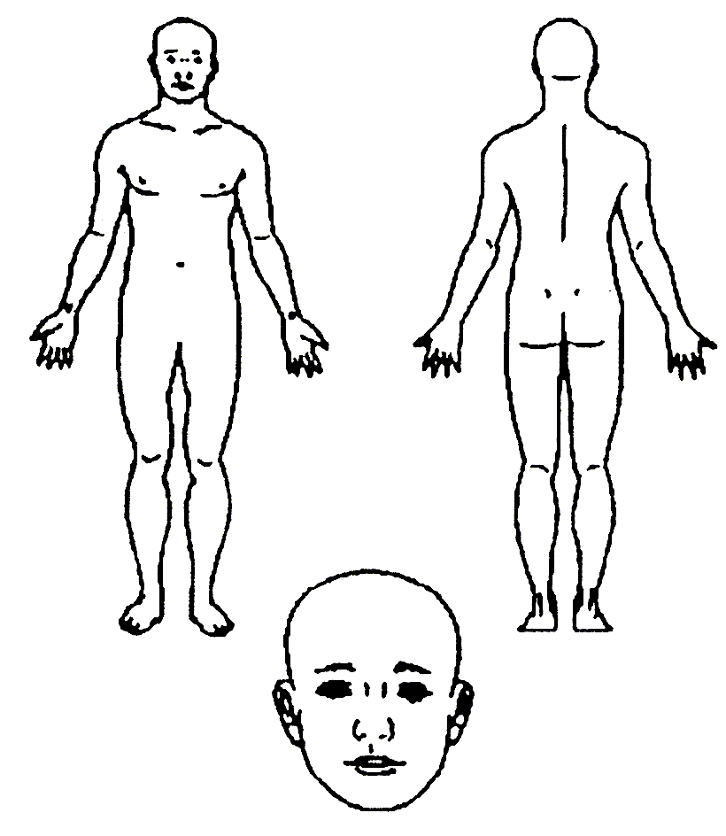  Body part/s  _________________________________  _________________________________ | Nature of Injury/Illness  - abrasion/graze  - sprain eg ligament tear  - strain eg muscle tear  - open wound/laceration/cut  - bruise/contusion  - inflammation/swelling  - fracture (including suspected)  - dislocation/subluxation  - overuse injury to muscle or tendon  - blisters  - concussion  - cardiac problem  - respiratory problem  - loss of consciousness  - unspecified medical condition  - other __________________________  Provisional diagnosis/es _____________  _________________________________  _________________________________  CAUSE OF INJURY  Mechanism of Injury  - struck by other player  - struck by ball or object  - collision with other player/referee  - collision with fixed object  - fall/stumble on same level  - jumping to shoot or defend  - fall from height/awkward landing  - overexertion (eg tear muscle)  - overuse  - slip/trip  - temperature related eg heat stress  - other _________________________ | Explain exactly how the incident occurred  __________________________________________  __________________________________________  ____________________________________________________________________________________________________________________________________________________________________________________________________________________________________________________________  Were there any contributing factors to the incident, unsuitable footwear, playing surface, equipment, rough play?  ______________________________________________________________________________________________________________________________  Protective Equipment  Was protective equipment worn on the injured body part?  - yes  - no  If yes, what type eg ankle brace, taping.  _________________________________________  Initial Treatment  - none given (not required)  - RICER  - sling, splint  - massage  - dressing  - crutches  - manual therapy  - stretch/exercises  - CPR  - strapping/taping only  - none given - referred elsewhere  - other __________________________ | Advice Given  - immediate return unrestricted activity  - able to return with restriction  - unable to return at present time  Referral  - no referral  - medical practitioner  - physiotherapist  - chiropractor or other professional  - ambulance transport  - hospital  - other __________________________  Provisional severity assessment  - mild (1-7 days modified activity)  - moderate (8-21 days modified activity)  - severe (>21 days modified or lost)  Treating person  - medical practitioner  - physiotherapist  - nurse  - sports trainer  - other __________________________  Signature of treating person  __________________________________________________________________  Today’s Date: __/__/__

MININERA & DISTRICT NETBALL ASSOCIATION
ADMINISTRATION GUIDE

GRADES

Junior Section:

13 & Under Female 4 x 10 minute quarters
15 & Under Female 4 x 10 minute quarters
18 & Under Female 4 x 12 minute quarters

Senior Section:

A Grade Female 4 x 15 minute quarters
B Grade Female 4 x 12 minute quarters
C Grade Female 4 x 10 minute quarters

TIME SCHEDULES

Two Courts:

10.00am 13 & Under Female - 18 & Under Female
11.00am 15 & Under Female - C Grade Female
12.00pm B Grade Female
1.00pm A Grade Female

One Court:

10.00am 13 & Under Female
11.00am 15 & Under Female
12.00pm 18 & Under Female
1.00pm C Grade Female
2.00pm B Grade Female
3.00pm A Grade Female

All matches will be played in accordance with the Mininera and District Football League Draw. The home club is the first named on the fixture.

Any alteration to time schedule must be ratified by Mininera and District Netball Association Executive.

Any scheduled day/night games must be done in accordance with consultation of MDNA Executive.

MININERA & DISTRICT NETBALL ASSOCIATION
ADMINISTRATION GUIDE

RISK MANAGEMENT
The Mininera and District Netball Association aims to provide a safe, welcoming and inclusive environment for all participants.
We have the following risk management guidelines:
SmokeFree Policy- eg. designated smoke free areas.
Sunsmart Policy – eg. promoting use of sunscreen and hats.
Netball Victoria Codes of Behaviour – guidelines for behaviour for parents, administrators, coaches, players, umpires and spectators. These to be displayed in clubroom.
Child Safe Standards
Injury Reporting/Form
Incident Reporting/Form
Screening for Squad Teams/Personnel
Worksafe banners to be displayed around court area.
Worksafe badges to be included on player bibs.
Working with Children’s Checks –
Associations, Leagues and Clubs affiliated with Netball Victoria are required to adhere to the WWWC regulation under rule 35 of the Netball Victoria Constitution.
What is the Netball Victoria Regulation?
All Netball Victoria Associations, Leagues and Clubs must at all times:
1. ensure that each adult (18 years and older) who seeks to hold, or currently holds, a position of responsibility or authority with children (under 18 years of age) has direct contact with children or who is otherwise required by law to maintain a valid Working with Children Check must seek and maintain a valid working with children check. "A person in a position of responsibility or authority" includes; directors or committee members of the Association, League and Club, coaches, umpires, officials (whether accredited or not), team managers and other senior positions (paid or unpaid), appointed or ad hoc, whether supervised or not.
2. keep a register of all members or persons within the Association, League and Club who hold a working with children check. Where an adult seeks, or is in, a position of responsibility or authority with an Association, League and Club: (a) and refuses to seek a working with children check; or (b) applies for, but is refused, a working with children check; then that person is ineligible to assume or continue with the position of responsibility or authority. For the avoidance of doubt a person must obtain a working with children check before they are eligible to assume the position of responsibility or authority within an Association, League and Club.”

MININERA & DISTRICT NETBALL ASSOCIATION
ADMINISTRATION GUIDE

FINALS

Times for Finals

GRADES | QUARTERS | ALL FINALS
13 & Under Female | 10 Minutes | 9.00am
15 & Under Female | 10 Minutes | 10.00am
18 & Under Female | 12 Minutes | 11.15am
C Grade Female | 10 Minutes | 12.30pm
B Grade Female | 12 Minutes | 1.45pm
A Grade Female | 15 Minutes | 3.00pm

Intervals

3 Minutes between 1st and 2nd Quarter and 3rd and 4th Quarter
5 Minute interval at ½ time

Injury Time

As per normal injury / illness / blood time

Drawn Matches - Finals

- During intervals substitutions and/or team changes may be made.

- There shall be a two (2) minute interval at the end of full time.

- Teams shall change ends at the end of full time.

(d)(i) Extra time shall consist of two (2) halves of :

A Grade, B Grade, 18 & Under 5 minutes

13 & Under, 15 & Under, C grade 3 minutes

with an interval of one (1) minute at half time. Teams shall change ends at half time. The centre pass is taken by the team entitled to the next centre pass.

(ii) For the 2nd half of extra time, timekeepers shall set the timer to count upwards so as not to distract the bench side umpire.

(iii) In the event of a tie remaining at the end of extra time, a visual signal shall be used to indicate that play shall continue until one team has a two (2) goal advantage.
Visual signal to be used will be a laminated red square as provided by the MDNA Executive.
MININERA & DISTRICT NETBALL ASSOCIATION
ADMINISTRATION GUIDE

Order of Play for Finals
Saturday Qualifying Final (2nd plays 3rd)
Sunday Elimination (4th plays 5th)
Saturday 2nd Semi Final (1st plays winner of Qualifying Final)
Sunday 1st Semi Final (Loser of 2nd Semi Final plays winner of 1st semi final).
Saturday Preliminary Final (Loser of 2nd Semi Final plays winner of 1st Semi Final)
Saturday Grand Final (Winner of 2nd Semi Final plays winner Preliminary Final)

CLUB REQUIREMENTS FOR HOSTING FINALS

Courts and Facilities

- Court Match Day Checklist to be conducted by (2) Executive Members
- Court surrounds are swept.
- The 2nd court (if available) should be set up ready in case it is required.
- Team benches placed at correct distance from court and distinct from spectator area.
- Adequate change rooms, showers and toilets are provided
- Scoreboard attendants
• One Scoreboard – MDNA will provide the other one
• Hooter
• Towel for wiping the ball
• Blood kit
• MDNA has timers and pens etc
• MDNA will provide PA system for the Grand Final – Contact David Wade

Umpires and Executive

- Separate change room provided.
- Tea/Coffee facilities provided.
- Provide adequate lunch (hot & cold) and afternoon tea.
- 2 Reserved parking spaces for Executive
- 2 Reserved parking spaces for umpires.
Competing clubs should provide their own first aid kits, ice and blood kits for their own use.
We would prefer team benches and scorers to be on the same side of the court, however we realise this is not always possible.
In addition to the above guidelines, you will also need to provide a reserved car space for Anne-Maree Huglin. Barbara Bibby, Heather Higgins, Debbie McGeachin-Woff and Jill Wade. It is advisable to contact these ladies to confirm if they will be attending.

Umpires will also need to be allowed free entry. We will get a list of names to you in due course.

Grand Final Day
- PA System – Currently supplied by MDFL
- Table for Trophies
- Provision for sponsorship Display

MININERA & DISTRICT NETBALL ASSOCIATION
ADMINISTRATION GUIDE

TROPHIES

Trophies to be Returned Each Year

Perpetual Premiership Trophies:
A Grade (Cup)

Trophies To Be Purchased Each Year

Premiership Cups
A grade Female B grade Female C grade Female
18 & under Female 15 & under Female 13 & under Female

Best and Fairest and Runner Up Trophies
A Grade Female
B Grade Female
C Grade Female
18 & Under Female
15 & Under Female

Best in Finals Medallions
A Grade Female
B Grade Female
C Grade Female
18 & Under Female
15 & Under Female
13 & Under Female

Premiership Medallions (Gold) (Purchase 12 + Coach for each grade)
A Grade Female B Grade Female C Grade Female 18 & Under Female
15 & Under Female 13 & Under Female

Runner-UpMedallions (Silver)
(Purchase 12 + Coach for each JUNIOR grade)
18 & Under Female 15 & Under Female 13 & Under Female

MININERA & DISTRICT NETBALL ASSOCIATION
ADMINISTRATION GUIDE

ASSOCIATION REPRESENTATIVE TEAMS

The Mininera and District Netball Association select representative teams in the following grades:

13 & Under, 15 & Under, 17 & Under and (occasionally) Senior

2005 – The MDNA held a Junior Lightning Premiership from which it named players to attend training sessions from which the final squad was selected. Whether or not a Junior Lightning Premiership is held each year is an annual decision.

Players were sent an official “letter” inviting them to attend the two training sessions at which the teams were announced at the latter.

Players will be required to attend training session/s. If unable to they will be required to notify their respective coach/selector or Squad Co ordinator, MDNA Executive of their intentions.

All players will be required to fill in a Medical Indemnity Form which will be used for the purposes of allowing those responsible to player’s update, current medical information. These indemnity forms will be kept in the hands of Secretary at the conclusion of the current season.

The Mininera and District netball Association appoint a SQUAD CO-ORDINATOR whose role it is to

Co ordinate Squad Teams annually
Organise in consultation with Executive training dates/times/venue
Organise ‘entry’ into tournaments
Co ordinate coaches, umpires etc

Nominations for Coaches and Umpires will be called for at the beginning of Netball season.

The MDNA Executive will be responsible for the issuing of Invites to prospective players to attend training sessions and to extend a ‘thankyou” to those who participated during the season.

All Squad Members will receive an invite to the Annual Presentation Evening.

The MDNA have a current Screening Policy as part of its Member Protection – please refer to this in the Member Protection Booklet.

All coaches to have a “Working with Children’s Check” and at the very minimum Development Coaching accreditation

INDEMNITY FORM

The following is a sample of the Indemnity and Consent Form to be used by the MDNA for its players, coaches and officials.

PERSONAL AND MEDICAL INFORMATION

Associations/clubs may request players, coaches and officials to complete a personal and medical form to obtain information that would assist them in the event of an injury, illness or emergency.

Players, coaches and officials are not required to provide any information requested.

Any information provided is confidential. The MDNA must indicate who will be privy to the information provided. Other people should not be provided with access to this information without the consent of the person in question.

CONSENT

Associations/clubs should obtain parental consent for players under the age of 18 to participate in any competition or event.

In order to satisfy its duty of care the MDNA should provide players (and in the case of players under the age of 18, the parent) with information regarding the rules and conditions of the competition/event and the potential risks involved in participating in netball. ie injury risks.

INDEMNITY

Note that any indemnity included in the form that states that "the Association/club will be absolved from all liability " does not in fact remove the right of an individual to take legal action against the Association/club at any stage. However, obtaining personal and medical information will enable the Association/club to respond appropriately in an emergency and this will mitigate the risk of loss, damage or liability.

INDEMNITY & CONSENT FORM

PERSONAL AND MEDICAL INFORMATION

I hereby consent to the provision of the following health information for the Mininera and District Netball Association records and to use in the event of injury, illness or emergency, if required.

The Mininera and District Netball Association requires the information requested below for use in relation to the Squad competition/s. Your personal information will only be used in the event of injury, illness or emergency, if required. Your details will be disclosed to the following Association personnel: Association Secretary, Team Coach, and Team Manager. You will be able to access your personal information through MDNA upon reasonable notice.

Name:
Address:
Postcode
Phone No.: NV Membership No:
Date Of Birth: Age:
Medicare No.:

If applicable:

Private Health Insurance Company: No.
Ambulance Member No.:
Existing Medical Conditions/Injuries/Allergies:

Regular Medication:
Next Of Kin (1): Daytime Phone No:
After hours Ph No:
Next Of Kin (2): Daytime Phone No:
After hours Ph No:

CONSENT: I understand that the Association competition will be played under the rules as set by Mininera Netball Association in accordance with Netball Victoria guidelines. I also understand that netball is a limited contact sport and that there is a risk of injury involved in playing netball. I authorise any official from Mininera & District Netball Association in charge of the Association Event/competition/program, in the event of any injury or illness, to obtain on my behalf and at my expense any medical assistance, treatment and transportation as deemed necessary.

INDEMNITY: Except where provided or required by law and such cannot be excluded, I agree that Mininera and District Netball Association and its respective directors, officers, members, servants or agents are absolved from all liability however arising from injury or damage to me, however caused, arising whilst participating in the Association competition.

I have read, understood and agree to the above terms. I warrant that all information provided is true and correct.

Signed (player): ___________________________________ Date: _____________ _______

I have read, understood and agree to the above terms and I personally consent to the application of my child. I warrant that all information provided is true and correct.

Signed (parent/legal guardian): ______________________ Date: __________________________

MININERA & DISTRICT NETBALL ASSOCIATION
ADMINISTRATION GUIDE

ROLE OF THE COURT SUPERVISOR
1. Each Club will annually nominate a person/s to act in the role of Court Supervisor.
2. The Court Supervisor will be responsible for conducting the Match Day Checklist prior to the commencement of the days play with the opposition Court Supervisor.
3. The Court Supervisor is required to sign and date the Match Day Checklist weekly. This is to be retained on file at the club.
4. In the case of extreme weather conditions which cause concern to player or officials’ safety, the Court Supervisors have the power to ‘abandon’ play or reduce court playing time at any stage of the day. This is the responsibility of the court supervisors – not the umpires.
5. Court supervisors should ensure that only players, team officials, umpires, and bench
officials are within the court enclosure while matches are in progress. The court official has the power to evict anyone not directly involved in the match. Clubs should show respect and do their utmost to communicate this requirement to their members.
6. During the finals, the Association Executive will be responsible for completing the Match Day Checklist before the beginning of the days play.

Match Day Checklist Netball Australia
The completion of the Match Day Checklist should be carried out before the commencement of a match day. In conjunction with the property owner, associations and clubs may bear the responsibility of ensuring that the court and its surroundings are safe for participant engagement. This checklist serves as a means of recognising and potentially mitigating some risks. This checklist is a guide only. Please ensure you undertake your own risk management assessments.
- Responsibility for checklist completion:
• Depending on the competition type, an association representative should complete the checklist for centrally located venues, while club representatives are responsible for matches played on a home and away basis.
• An affiliated official (above 18 years old) should sign the declaration at the end of this checklist.
- Timing of checklist completion:
• Checklists should be finalised before the commencement of play. Any changes in conditions should prompt ongoing monitoring and reassessment throughout the day.
- Purpose of the match day checklist:
• Aims to assist officials in identifying some foreseeable risks, including evaluating the safety of the playing arena, cleanliness of the playing surface, absence of hazards around the court and regular monitoring of facilities used for netball. This checklist is a guide only. Please ensure you undertake your own risk management assessments.
- Managing identified risks:
• Risks identified in the checklist should be documented along with the actions taken to mitigate them.
• Some strategies that may address certain risks include:
o Mitigate the risk: perform court sweeping, cordon off hazardous zones, or adjust the game format, as well as what is required based on your own risk assessment.
o Minimise the risk: eliminate hazardous objects from the area, consider delaying, postponing, or relocating games as well as what is required based on your own risk assessment.
o Transfer the risk: implement warning signs (e.g. slippery when wet) or issue written notices to relevant third parties (e.g. council) as well as what is required based on your own risk assessment.
- Conditions changing during the day:
• Continuous assessment of playing conditions is important.
- Responsibility and accountability:
• Signing the declaration indicates that the designated areas have been inspected.
- Handling completed checklists:
• All completed and signed checklists should be retained on file for a minimum of seven (7) years for future reference.

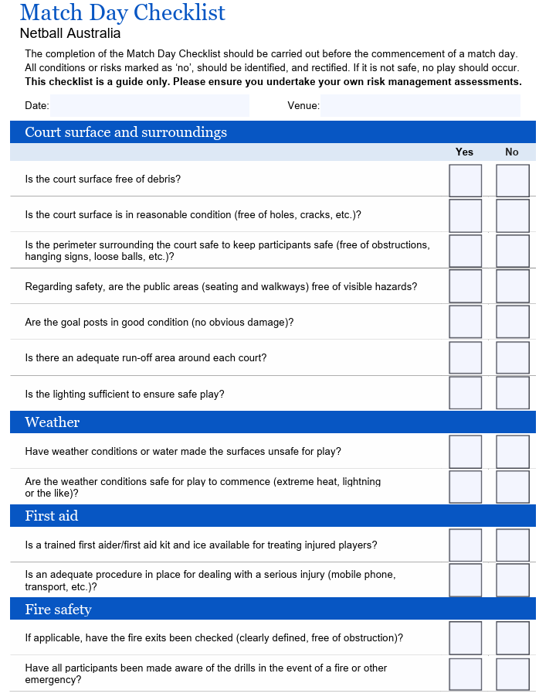

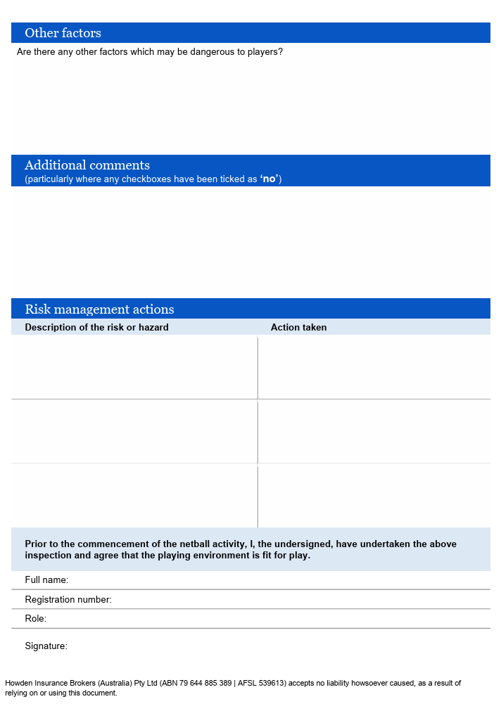

A few other reminders:

Be familiar with By laws relating to conduct of games:

4.5 In the case of extreme and intolerable weather conditions, where players health and safety become a concern or any other exceptional circumstances the game can be abandoned after consultation between umpires and court supervisors.

(a) If play has not commenced or has commenced and is abandoned prior to half time, two (2) points shall be awarded to each team. No percentage shall be recorded.

(b) If the match is abandoned after half time, the score at that time will stand and will be classed as the final result.

(c) One full half must be played for Best and Fairest Votes to be awarded for that match.

(d) Score sheets, signed by an official from each club & the Court Supervisors, and must be forwarded to the Recorder after all abandoned matches.

Remember you can abandon one game due to circumstances and still play rest of day’s games if conditions improve. The decision to continue to play or not must be done 15 minutes after original starting time. This can be done for each individual time slot.

(e) Teams must allow girls who have umpired, coached or played in the previous match, a reasonable amount of time to be able to take the court for the following game.

The Court supervisor can nominate another person/s during the day – important that both clubs be informed – if this is to be done – we encourage an (am) and a (pm) person to be appointed.

Any discussion needs to be only done between two court supervisors and should be done away from the court and vision of players and other personnel.

If no agreement is reached – then the game will be concluded and score sheets not signed by officials and an Incident report completed.

Court Supervisor is not to be a player/coach/official during the course of their match.
Be prepared to put safety as top priority – you will always be supported!

MININERA & DISTRICT NETBALL ASSOCIATION
ADMINISTRATION GUIDE

ROLES AND RESPONSIBILITIES

Purpose: To Promote and enhance netball within the Mininera and District Netball Association.

PRESIDENT:

Principal user of Netball Connect – or appoint a Principal user as appropriate
Chair meetings effectively
Facilitator of Association activities - Should ensure that they are carried out in accordance with the wishes of the MDNA delegates
Be well informed of all organisation’s activities
Plan and be aware of future directions
Discuss the agenda items before hand with Secretary
Oversee and assist other committee members
Plan and budget for coming season and future
Link between members, clubs and any other outside bodies - MDFL, Netball Vic,
Develop sponsorship letters/records
Oversee applying of grants
Casting vote when required
Maintain confidentiality on relevant matters
Call for nominations for Executive & other positions for the MDNA AGM

ADMINISTRATION SECRETARY:

Record all Minutes
Prepare Agenda and post with Minutes
Assist planning of events and activities
Check mail and see President with all correspondence
Prepare and send any outward correspondence
Maintain necessary records of Association, such as constitution & By-laws
Communicate information between Association/Club members such as important dates & events etc
Liaise with President & other committee members when required
Receive nominations for Executive & other positions for the MDNA AGM
Notify clubs in writing of any fines that a club is required to pay

TREASURER:

Manage financial affairs of Association
Communicate closely with President and Secretary re: Associations finances
Receipt all moneys received
Prepare budget for the forthcoming year
Maintain accurate records of current income and expenditure
Prepare annual financial accounts for auditing
Monitor sponsorship funds

DISPUTE RESOLUTION

All disputes will be dealt with in accordance with Netball Victoria Competition Regulations

VICE PRESIDENT:
Attend Association meetings
Be prepared to Chair meetings at any given time
Duties as directed by the President

RECORDER:
Receives emailed copies of score sheets and check details on Netball Connect weekly
Confirms on Netball Connect when all data is correct
Monitors games played for qualification purposes.
Check finals teams to make sure players are qualified.

MEDIA OFFICER;
Responsible for posting information as directed by the President on the MDNA facebook page and the MDNA website. This includes updating the By-laws, Administration Guide, Executive contact details and other information annual or as required.
Assist with reports to media outlets for finals and as requested.

ROSTERED CLUB - VOTE COUNT & FINALS
The Rostered Club is responsible for organising in conjunction with the Executive the
Annual Vote Count Evening
Providing assistance during finals series
Any duties as required by the Executive

UMPIRES CO ORDINATOR
Facilitate umpiring activities within the Association along with Executive
Assist co ordination of umpires for the finals
Provide support to individual clubs as required

BY LAWS OFFICER
Prepare current version of M&DNA By Laws

HEARINGS OFFICER
Responsible for management of grievances

SQUAD CO ORDINATOR
Co ordinate Squad Teams
Organise in consultation with Executive training dates/times/venue
Organise ‘entry’ into tournaments
Organise in consultation with Executive, coaches and umpires.

NETBALL CONNECT CO-ORDINATOR
Set-up the draw for the current season and assist clubs with setting up their online registration page
Attend to enquiries from members and resolve issues in consultation with the executive
Update ladders weekly once all results are entered. Generate email to subscribers weekly.

Umpire Mentor Guidelines

Before you get started – Plan your attack!

Don’t just turn up and give advice from the sideline – this is not mentoring it’s just supporting, which is important too, but for the process to be mutually beneficial, a true mentor/trainee relationship needs a plan.
Have you done or considered doing the online Mentors course? This is a great starting point for you as a mentor. To access this course, log in to your Netball Connect account.
Is your own education up to date – ie: have you done the Rules of Netball Theory Exam recently and the Foundation Umpire Education Course. Both are online through Netball

Once you have made sure you are ready to mentor, consider the following:
Mentors and trainees should be compatible with each other and be able to exchange thoughts and ideas freely, so it is important for beginner (and experienced) umpires to find a mentor they are comfortable with.
Ideally, the mentor and trainee should develop an action plan which includes things like:
• Your expectations of each other
• Set a goal - eg: to have your beginner ready to tackle their first match by a certain date.
Once that is achieved, set the next goal eg: to umpire the next level up by a certain date.
It’s handy to have a long-term target eg: be ready to be tested by a certain date
• Commit to so many hours per week/month. Work out a timetable for when you are available to each other, set times and be accountable by keeping appointments
• Work out what kind of feedback works best for your trainee. Do they need constant feedback, do they cope better with just a little bit of information at once, are they able to digest verbal information or do they respond better to visual examples? Plan how you are going to to do this.
• Be familiar with the level of knowledge your trainee umpire has.
Before rushing into the practical side of umpiring, have them do the online exam and Foundation course. These are both prerequisites to being tested, so why not get them out of the way early? You will soon find out how keen and committed your trainee is you and the time you are giving them. There are also a number of practice exams on the MDNA website that might be useful.
• There are a few of other umpire resources on the MDNA site. Two in particular that I would encourage the trainee to read are the Match Protocols and the Frequently Asked Questions.
• Read your rule book regularly and keep abreast of any changes.

Prior to umpiring their first match
Mentors should sit with their trainees to watch a full match and discuss the game. This gives the trainee the opportunity to ask questions during the match and for mentors to point out things to watch for.
Mentors are encouraged to have their trainee umpires spend at least 2 matches sitting at the score bench whilst their mentor is umpiring, prior to taking charge of a match themselves. This enables the trainee to observe a match and procedures without distraction from the spectators. It’s not just about the rules!
The trainee umpire can participate in the pre-game checks alongside the mentor and the other umpire, including nail and adornment checks, being advised of the outcome of the coin toss between captains and conducting the coin toss with the other umpire.
This also gives the trainee access to the umpires at the breaks so they can hear any discussions between the on-court umpires.
The mentor should make sure their fellow umpire is ok with this arrangement first.
Mentors should make sure their trainee is ready to umpire a Saturday match. Nothing turns an umpire off quicker than being thrown in when they aren’t ready and having a really bad experience on their first match. The players also deserve an umpire who is competent.
Mentoring your umpire during a match
In the MDNA the mentor needs to wear the pink umpire vest. This is more of a visual signal to the spectators that you are assisting an umpire and not just a person who is in the playing enclosure when otherwise you shouldn’t be!
Mentors are not permitted to carry or use a whistle.
Mentors shouldn’t “run with” their trainee umpire. There is nothing more distracting then having someone chatting in you ear while you are trying to concentrate or getting in the way when you need to change directions quickly.
The mentor should place themselves in the corner of the playing enclosure at their trainee’s goal end. The only things you should be saying to your trainee during the match is reminding them of their positioning, changing their band after a goal and signalling the centre. They might need to be told to blow louder and use their voice and hand signals. You have already determined that they have the rule knowledge to umpire the match so don’t make decisions for them from the sideline.
Do, however, have a pen and paper to jot down any issues that need working on and this could be rule based decisions. You will use these notes during your time with the trainee to give feedback afterwards – but not during the match.
Trainees shouldn’t be looking to their mentor to make decisions, but mentors should be available to help with game management issues if the umpire has held time and, in consultation with their fellow umpire, are looking to you for advice. Game management issues can be scary for both beginner and experienced umpires!
Give advice at breaks only, but don’t overwhelm them with too many instructions. Again, this advice should be limited to directions on positioning. Make sure the umpires check with each other, then the scorers for next centre after the break.
Keep reassessing the goals you put in place at the beginning of your relationship and be prepared to change plans if needed.
Being prepared is key to both the mentor and trainee getting the most out of the experience!

MININERA & DISTRICT NETBALL ASSOCIATION
ADMINISTRATION GUIDE

Clubs on a rotational basis WILL BE RESPONSIBLE FOR all positions not filled by means of nominations received prior to the AGM or from the floor at the AGM.
[refer by-law 13.3 (d)]

Club rotation roster:

2017 Hawkesdale Macarthur 2024 SMW Rovers
2018 Glenthomspon Dunkeld 2025 Woorndoo Mortlake
2019 Tatyoon 2026 Wickliffe Lake Bolac
2020 Great Western (no season) 2027 Moyston Willaura
2021 Great Western 2028 Penshurst
2022 Lismore Derrinallum 2029 Ararat Eagles
2023 Caramut 2030 Hawkesdale Macarthur

MININERA & DISTRICT NETBALL ASSOCIATION
ADMINISTRATION GUIDE

Criteria for Life Membership to the Mininera and District Netball Association

This award exists to recognise the valuable contribution of individuals to the Mininera & District Netball Association (MDNA.)

To be considered for the award of Life Membership, an individual will have demonstrated
significant, sustained and high-quality service to the MDNA, which has enhanced the reputation and future of the Association.

A nomination can be submitted by anyone.
It must be in writing and include a comprehensive list of the nominees’ involvement in the MDNA over the length of their service - ie: playing history, club or Association volunteer involvement and Association executive involvement.

The nomination needs to be submitted to the Administration Secretary of the MDNA, on the appropriate ‘Nomination Form’, by 31st July of the current season.

In order to decide if the Life Membership is to be awarded to the nominee, at least 2 members of the executive will consult with a current life member and a person with no involvement with the Association or its affiliated clubs.
All nominations are to be treated confidentially.

Nominees are required to meet the following criteria to qualify for consideration as a Life Member.
Meeting the criteria DOES NOT guarantee that a nominee will be awarded Life Membership.

• 20 years of involvement with the MDNA as either a player, club official, Association committee member or a combination of these.

• Shown consistent interest, dedication, motivation and enthusiasm towards netball and the MDNA.

• Held an Association position – Executive or other position.

• Had an involvement with Association squad teams – as a player, umpire or coach.

• Held an Association Delegate position.

Privileges of Life Membership

• Exemption from gate entrance fees for the Life Member and her/his partner for all association matches, including finals.
• Personal invitation to the Association presentation evening and other official MDNA functions.
• Reserved car park at all finals

MININERA & DISTRICT NETBALL ASSOCIATION
LIFE MEMBERSHIP NOMINATION FORM

Dated: _______________

This form is to be submitted to the Administration Secretary of the
Mininera & District Netball Association for consideration for Life Membership by 31st July.
.
Nominees must meet the Criteria for Life Membership to the Mininera and District Netball Association

Name of Nominee:
Nominated by:
Date Submitted:
Nominees Qualifications | Please attach as a separate document

Mininera and District Netball Association
Inc. A004733K

Clubs affiliated: Ararat, Caramut, Glenthompson Dunkeld, Great Western, Hawkesdale Macarthur, Lismore Derrinallum, Moyston Willaura, Penshurst, SMW Rovers, Tatyoon, Wickliffe Lake Bolac, Woorndoo Mortlake

INCIDENT REPORTING FORM
(Please tick appropriate box)

□ Hazard/Potential Hazard – (1 form to be completed and signed by both clubs if required)
□ Inappropriate Behaviour – ( 1 form per club to be completed and signed)
□ Competition Related Dispute – (1 form per club be completed and signed)

Person Reporting Incident/Hazard:

Name:__________________________________________________________________________

Address:_________________________________________________________________________

______________________________________________________________ P/Code:_________

Phone: (BH):______________________________________(AH):________________________________

Email:__________________________________________________________________________

Incident/Hazard Details:

Venue:

________________________________________________________________________________

Date of hazard/incident:

__________________________________________________________________________

Time of hazard/incident:

__________________________________________________________________________

Exact location of hazard/incident:

__________________________________________________________________

Provide a detailed description of the incident:

Witness Contact Details

Witness Name: ________________________________________________________________________________

Phone: (BH):_____________________________________________(AH):_________________________

Email:__________________________________________________________________________

Outline any action taken at the time of the hazard/incident.

Signed: ______________________________________________Date:________________________

Action taken: (Please tick)

□ Both coaches are aware of the Incident
□ Both players/parties involved have been spoken too.
□ Club President/Secretary/Netball Executive Member are aware of the Incident
□ Are you happy with the outcome?

What outcome would you like achieved?

Signed: __________________________________________________________________________
(Home Club) (Away Club)

Form to be lodged with the Association President or Administration Secretary
OUTDOOR FACILITY GRADING SHEET
The following grading sheet can be used to conduct a self-assessment of outdoor courts within the Mininera and District Netball Association. This sheet can be used to (a) assist with long term planning to upgrade and/or develop new facilities and (b) support funding applications to local council for upgrading/improving the court surface and general netball amenities.
Please tick the appropriate response for each section.

Association/Club Name:_________________________________________________________________

RATING | - SURFACE TYPE | CRITERIA
 | A | Synthetic (<5-8 years old) or High quality hot mix asphalt (< 5 years old)
 | B | Synthetic (>8 years old) or High quality hot mix asphalt (> 5 years old)
 | C | Low quality asphalt (road mix)
 | D | Concrete or grass
 | - SURFACE CONDITION
 | A | Excellent quality  Free from surface imperfections including:  cracking (hairline to severe), gravel, undulations, fittings for other sports (ie tennis hole caps), water retention (filled with water indentations which cover 20c piece), mould, mildew, leaves or sticks
 | B | Good quality  Some surface imperfections
 | C | Poor quality  Serious surface imperfections (not playable)
 | - COURT LINE CONDITION
 | A | Excellent quality  Clear and well marked , waterbased or polyurethane, not multilined (ie. for other sports)
 | B | Good quality
 | C | Poor quality
 | - COURT SIZE
 | A  Note if B or C rating, must indicate run-off distance on court diagram over page. | National/International standard  - 30.5metres x 15.25 metres  - Goal circle radius - 4.9 metres  - Centre circle diameter - .9 metres  - Court line width - 50 mm  - Run Off - to goal line & seating - 3.05 metres, between courts - 3.65 metres  - Warm up area
 | B | National/International standard with variable run offs (indicate run-offs over page)
 | C | Short or narrow courts with variable run offs (indicate run-offs over page)
 | - GOAL POSTS
 | A | Excellent standard including:  vertical height of 3.05 metre, adjustable to 2.4 metres for Netta, padding, fully inserted into ground
 | B | Good standard
 | C | Poor standard
 | - CAR PARKING
 | A | Purpose built car parking including  line marking, clearly marked traffic direction arrows, disabled spaces, access to courts for ambulance or car, security lighting
 | B | Good car parking
 | C | No car parking facilities
RATING | - COURT SURROUNDS
 | A | Excellent condition including:  Landscaping, no overhanging trees or shrubs, shade trees or shelters
 | B | Good condition
 | C | Poor condition

 | - CLUB ROOMS
 | A | Excellent including:  - First Aid facility including running water  - Non slip surfaces  - Meeting room  - Office  - Equipment storage  - Creche  - Central timing  - Secure umpiring room | - Toilets (secure & adequate number – including disabled)  - Change rooms  - Canteen  - Heating  - Impact protection - Glass windows  - Adequate electrical outlets  - Safe electrical appliances  - Fire fighting equipment available  - Fire exits marked
 | B | Good
 | C | Poor
 | - ASSOCIATED FACILITIES
 | Scoring Shelters
 | Seating
 | Drink fountains
 | Court lighting
 | Rubbish bins with lids

On the diagram below, please illustrate any surface imperfections (ie cracking, undulations etc.), detailing the problems in proportion to court size. Also provide run-off distances around the edge of the courts for both sides and ends eg: 2.5 metres
Run-off

Run-off

MININERA AND DISTRICT NETBALL ASSOCIATION

WHISTLE AWARD

NOMINATION
(To Executive – no later than Sunday after last home and away game)

NAME:

……………………………………………………………………………………………………

CLUB:

……………………………………………………………………………………………………

NOMINATED BY:

………………………………………………………………………………………

SIGNATURE

…………………………………………………………………………………………….

HISTORY:

……………………………………………………………………………………………….

………………………………………………………………………………………………………

…………………………………………………………………………………………………………

………………………………………………………………………………………………………

…………………………………………………………………………………………………………

…………………………………………………………………………………………………………

…………………………………………………………………………………………………………

…………………………………………………………………………………………………………

…………………………………………………………………………………………………………

…………………………………………………………………………………………………………

…………………………………………………………………………………………………………

MININERA & DISTRICT NETBALL ASSOCIATION
ADMINISTRATION GUIDE

NETBALL CONNECT JOB LIST

(Please remember that we are all in this together and we are going to have some challenges – please be patient and understanding)

Ensure all players are entered on the team list by FRIDAY 12 noon to enable the home team time to print the scoresheets. Note: extra players can be added up until the start of the match but if scoresheets have already been printed, you will need to ensure the names are written on the scoresheet prior to the match.

HOME TEAM to print off score sheets and place in corresponding folder. (Suggest that you place something behind the scoresheet for ease of writing)

All JUNIOR results, best players and data for both teams to be in by 2pm Game day

All SENIOR grade results, best players and data to be in by 5.00pm Game day

Keep the scoresheets and email copy to the away team

Original score sheets to be emailed by the Monday following the match to Recorder –

mdnarecorder@hotmail.com

MDNA Recorder to confirm results and make “official” upon receiving score sheet and checking.

In the event that scores CANNOT be entered on the Netball Connect site –
Score sheet to be faxed to David Wade no later than 4.30pm Saturday evening. 55995399

Mininera and District Netball Association
Inc. A004733K

MININERA & DISTRICT NETBALL ASSOCIATION
ADMINISTRATION GUIDE

Clubs affiliated: Ararat, Caramut, Glenthompson Dunkeld, Great Western, Hawkesdale Macarthur, Lismore Derrinallum, Moyston Willaura, Penshurst, SMW Rovers, Tatyoon, Wickliffe Lake Bolac and Woorndoo Mortlake

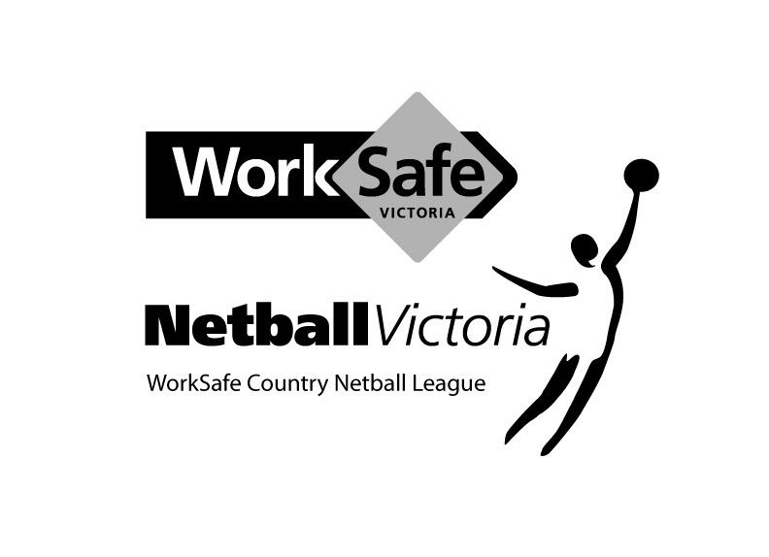

EXECUTIVE NOMINATION FORM

Position:

Name:

Is Nominated by:

Signature:

Seconded By:

Signature:

I accept this nomination

Signature of Nominee:

Date:

MININERA & DISTRICT NETBALL ASSOCIATION
ADMINISTRATION GUIDE

CODES OF CONDUCT

General behaviour

As a person required to comply with this Regulation, you must meet the following requirements in regard to your conduct during any activity held or sanctioned by Netball Victoria, a Region, an Affiliated Association or an Affiliated Club:
- Respect the rights, dignity and worth of others.
- Be fair, considerate and honest in all dealings with others.
- Be professional in, and accept responsibility for your actions.
- Make a commitment to providing quality service.
- Be aware of, and maintain an uncompromising adhesion to Netball Victoria’s standards, rules, regulations and policies.
- Operate within the rules of the sport including state guidelines which govern Netball Victoria, the Regions, the Affiliated Associations and the Affiliated Clubs.
- Do not use your involvement with Netball Victoria, a Region, an Affiliated Association or an Affiliated Club to promote your own beliefs, behaviours or practices where these are inconsistent with those of Netball Victoria, a Region, an Affiliated Association or an Affiliated Club.
- Demonstrate a high degree of individual responsibility especially when dealing with persons under 18 years of age, as your words and actions are an example.
- Avoid unaccompanied and unobserved activities with persons under 18 years of age, wherever possible.
- Refrain from any behaviour that may bring Netball Victoria, a Region, an Affiliated Association or an Affiliated Club into disrepute.
- Provide a safe environment for the conduct of the activity.
- Show concern and caution towards others who may be sick or injured.
- Be a positive role model.
- Understand the repercussions if you breach, or are aware of any breaches of this Code of Behaviour

MININERA & DISTRICT NETBALL ASSOCIATION
ADMINISTRATION GUIDE

CODES OF CONDUCT

Administrator Code of Behaviour

In addition to Netball Victoria's General Code of Behaviour, you must meet the following requirements in regard to your conduct during any activity held by or under the auspices of Netball Victoria, a Region, an Affiliated Association or an Affiliated Club and in your role as an administrator of Netball Victoria, a Region, an Affiliated Association or an Affiliated Club:
- Be fair, considerate and honest in all dealings with others.
- Be professional in, and accept responsibility for your actions. Your language, presentation, manners and punctuality should reflect high standards.
- Resolve conflicts fairly and promptly through established procedures.
- Maintain strict impartiality.
- Be aware of your legal responsibilities.
- Develop a positive sport environment by allowing for the special needs of the players (especially children), by emphasising enjoyment and by providing appropriate development and competitive experiences.
- Involve players in the planning, leadership, evaluation and decision making relating to the activity.
- Ensure activities, equipment and facilities are safe and appropriate to the ability level of participating players. Activities, rules, equipment, lengths of games and training schedules should take into consideration the age, ability and maturity level of participating players.
- Ensure that everyone (administrators, coaches, players, umpires, parents, spectators, sponsors and physicians) emphasise fair play in netball activities and games.
- Where appropriate, distribute a Code of Behaviour sheet to coaches, players, umpires, parents, spectators and the media.

MININERA & DISTRICT NETBALL ASSOCIATION
ADMINISTRATION GUIDE

CODES OF CONDUCT

Coaches Code of Behaviour

In addition to Netball Victoria's General Code of Behaviour, you must meet the following requirements in regard to your conduct during any activity held by or under the auspices of Netball Victoria, a Region, an Affiliated Association or an Affiliated Club and in your role as a coach of Netball Victoria, a Region, an Affiliated Association or an Affiliated Club:
Treat all players with respect at all times. Be honest and consistent with them. Honour all promises and commitments, both verbal and written.
Promote a climate of mutual support among your players. Encourage players to respect one another and to expect respect for their worth as individuals regardless of their level of play.
Encourage and facilitate players’ independence and responsibility for their own behaviour, performance, decisions and actions.
Involve the players in decisions that affect them.
Determine, in consultation with the players, what information is confidential and respect that confidentiality.
Provide feedback to players in a caring sensitive manner to their needs. Avoid overly negative feedback.
Refrain from any form of personal abuse towards your players. This includes verbal, physical and emotional abuse. Be alert to any forms of abuse directed toward your players from other sources while they are in your care. (Abide by Netball Victoria Member Protection Regulation).
Refrain from any form of harassment towards your players. Treat all players fairly within the context of their sporting activities, regardless of gender, race, place of origin, athletic potential, colour, sexual orientation, religion, political beliefs, socio-economic status, and other condition. (Abide by Netball Victoria Member Protection Regulation).
Be acutely aware of the power that you as a coach develop with your players in the coaching relationship and avoid any sexual intimacy with players that could develop as a result.
Avoid situations with your players that could be construed as compromising.
At all times use appropriate training methods which will benefit the players and avoid those which could be harmful. Ensure that the tasks, trainings, equipment and facilities are safe and suitable for age, experience, ability and physical and psychological conditions of the players.
Ensure the players time spent with you are a positive experience. All players are deserving of equal attention and opportunities. Provide training and game opportunities that ensure everyone has a reasonable chance to succeed and to improve/acquire skills and develop confidence.
Actively discourage the use of performance enhancing drugs, alcohol, tobacco and illegal substance. (Abide by the Netball Australia Anti-Doping Policy).
Recognise individual differences in players and always think of the player’s long-term best interests.
Set challenges for each player which are both achievable and motivating.
Respect the fact that your goal as a coach for the player may not always be the same as that of the player. Aim for excellence based upon realistic goals and due consideration for the participant’s growth and development.
At all times act as a role model that promotes the positive aspects of sport and of netball by maintaining the highest standards of personal conduct and projecting a favourable image of netball and of coaching at all times.
Recognise your player’s rights to consult with other coaches and advisers. Cooperate fully with other specialists (eg. sports scientists, doctors, physiotherapists etc).
Do not exploit any coaching relationship or information gained through Netball Victoria Programs, to further personal, political, or business interests.
Encourage players and coaches to develop and maintain integrity in their relationships with others.
Respect other coaches and always act in a manner characterised by courtesy and good faith.
When asked to coach, ensure that any previous coach- player relationship has been ended in a professional manner.
Accept and respect the role of officials in ensuring that competitions are conducted fairly and according to established rules. Know and abide by netball rules, regulations and standards, and encourage players to do likewise. Accept both the letter and the spirit of the rules.
Be honest and ensure that qualifications are not misrepresented.
Make a commitment to providing a quality service to your players. Provide a training program that is planned and sequential. Maintain or improve your current NCAS accreditation, seek continual improvement through performance appraisal and ongoing coach education and be open to other people’s opinion.

MININERA & DISTRICT NETBALL ASSOCIATION
ADMINISTRATION GUIDE

Junior Player Code of Behaviour

In addition to Netball Victoria’s General Code of Behaviour, as a player in any activity held by or under the auspices of Netball Victoria, a Region, an Affiliated Association or an Affiliated Club you must meet the following requirements in regard to your conduct during any such activity or event:

- Participate because you enjoy it, not just to please parents and coaches.
- Play by the rules:
• Know the rules
- Participate fairly and safely.
- Abide by decisions, without argument or bad temper.
Captains have the right to approach an umpire during an interval or after the game for clarification of any rule.
Approach the umpire in a courteous and polite way.
- Cooperate with your coach, and other players.
- Verbal abuse of officials or other players, deliberately fouling or provoking an opponent and throwing/damaging equipment is not acceptable or permitted.
- Treat all players, as you would like to be treated.
- Ensure that at all times your behaviour is fair.
- Be a patient and enthusiastic supporter of fellow players.
- Applaud all good play, by your own team and opponents.
- Be a responsible team member.
Always be on time.
Encourage and assist all players.
Attend all training sessions.
Ensure you always bring the appropriate uniform and equipment to training and/or matches.
- Do not engage in practises that affect sporting performance (alcohol, tobacco and drug use.)
- Respect and acknowledge the contribution of those who create the opportunity for you to play.
- Volunteers (scorers, coaches, timekeepers, administrators and umpires).
MININERA & DISTRICT NETBALL ASSOCIATION
ADMINISTRATION GUIDE

Senior Player Code of Behaviour

In addition to Netball Victoria’s General Code of Behaviour, as a player in any activity held by or under the auspices of Netball Victoria, a Region, an Affiliated Association or an Affiliated Club you must meet the following requirements in regard to your conduct during any such activity or event:

- Respect the rights, dignity and worth of fellow players, coaches, officials and spectators.
- Refrain from conduct that could be regarded as sexual or other harassment.
- Respect the talent, potential and development of fellow players and competitors.
- Care and respect the uniform and equipment provided to you.
- Be frank and honest with your coach concerning illness and injury and your ability to train and play fully.
- Conduct yourself in a responsible manner relating to language, temper and punctuality.
- Maintain a high standard of personal behaviour at all times.
- Abide by the rules and respect the decision of the umpires. Be courteous and use the correct process when seeking a rule clarification.
- Be honest in your attitude and preparation to training. Work equally hard for yourself and your team.
- Cooperate with coaches and staff in relation to programs that adequately prepare you for competition.
- Do not engage in practises that affect sporting performance (alcohol, tobacco and drug use.)

MININERA & DISTRICT NETBALL ASSOCIATION
ADMINISTRATION GUIDE

Umpire Code of Behaviour

In addition to Netball Victoria’s General Code of Behaviour, you must meet the following requirements in regard to your conduct during any activity held or sanctioned by Netball Victoria, a Region, an Affiliated Association or an Affiliated Club and in your role as an umpire appointed by Netball Victoria, a Region, an Affiliated Association or an Affiliated Club:
Treat all players with respect at all times.
Accept responsibility for all actions taken. Exercise reasonable care to prevent injury by ensuring players play within the rules. Reasonable care consists of advising the players of illegal body movements, showing due diligence in detecting infringements and penalising rule breakers.
Place the safety and welfare of the players above all else. Although it is the responsibility of umpires to ensure that the playing conditions are safe, in the end it is the association’s decision.
If a court supervisor or equivalent, is appointed and present at the match they would decide whether the game should commence or continue and deal with any emergencies relating to a safe environment or anticipate any foreseeable dangers and deal with it appropriately.
If no such person is present, you should make a decision as to whether the match should commence or continue due to adverse conditions, unsafe environment or foreseeable dangers.
Umpires must be impartial and maintain integrity in their relationship with other umpires, players and coaches.
Avoid situations that may lead to a conflict of interest.
Be courteous, respectful and open to discussion and interaction.
Value the individual in sport. Ensure the players have the opportunity for discussion with you after the match.
Seek continual self-improvement through study, performance appraisal and regular updating of competencies. Maintain or improve your current badge level and seek continual improvement.
Encourage inclusivity and access to all areas of officiating. Aim for excellence based upon realistic goals and due consideration for growth and development.
Be a positive role model in behaviour and personal appearance by maintaining the highest standards of personal conduct and projecting a favourable image of netball and umpiring at all times.
Refrain from any form of personal abuse towards players. This includes verbal, physical and emotional abuse. Be alert to any forms of abuse directed towards the players from other sources while they are playing. (Abide by Netball Victoria Member Protection Regulation).
Refrain from any form of harassment towards players. Treat all players fairly within the context of their sporting activities, regardless of gender, race, place of origin, athletic potential, colour, sexual orientation, religion, political beliefs, socio-economic status, and other conditions. (Abide by Netball Victoria Member Protection Regulation).
Show concern and caution towards ill and injured players. You should enforce the blood rule and apply procedures regarding ill or injured players according to the rulebook. Common sense must be applied in all cases.

MININERA & DISTRICT NETBALL ASSOCIATION
ADMINISTRATION GUIDE

Parent/Guardian Code of Behaviour

In addition to Netball Victoria’s General Code of Behaviour, as a parent/guardian of a player in any activity held by or under the auspices of Netball Victoria, a Region, an Affiliated Association or an Affiliated Club, you must meet the following requirements in regard to your conduct during any such activity or event:

- If your child is interested, encourage them to participate in the appropriate netball activity. However, if your child is not willing to participate, do not force him or her. Remember, children are involved in organised activity for their enjoyment, not yours.
- Focus upon your child's efforts and performance rather than the overall outcome of the event. This assists your child in setting realistic goals related to his/her ability by reducing the emphasis on winning.
- Teach your child that an honest effort is as important as victory, so that the result of each game is accepted without undue disappointment.
- Encourage your child to always play according to the rules.
- Never ridicule or yell at a child for making a mistake or losing a game.
- Remember that children learn best from example. Applaud good play by all players.
- If you disagree with an umpire or coach raise the issue through the appropriate channels rather than question their judgement and honesty in public.
- Support all efforts to remove verbal and physical abuse.
- Recognise and respect the value and importance of volunteer administrators, coaches and umpires. They give up their time and resources to provide recreational activities for players and deserve your support.
- Be a model of good sports behaviour for children to copy.
- Be courteous in communication with administrators, coaches, players and umpires. Teach children to do likewise.
- Support the use of age appropriate development activities and modified rules.

MININERA & DISTRICT NETBALL ASSOCIATION
ADMINISTRATION GUIDE

Spectator Code of Behaviour

In addition to Netball Victoria’s General Code of Behaviour, as a spectator in any activity held by or under the auspices of Netball Victoria, a Region, an Affiliated Association or an Affiliated Club, you must meet the following requirements in regard to your conduct during any such activity or event:

Most players (in particular children) participate in netball activities for fun. They are not participating for entertainment of spectators only.
Applaud good performance and efforts by all players. When watching a game congratulate both teams upon their performance regardless of the game's outcome.
Respect the umpires’ and coaches decisions. If there is a disagreement, follow the appropriate procedure in order to question the decision and teach children to do likewise.
Never ridicule or scold a player for making a mistake during a competition. Positive comments are motivational.
Condemn the use of violence in any form, be it by administrators, coaches, players, umpires or parents/guardians.
Show respect for your team's coach, the umpire and opponents. Without them there would be no game.
Encourage players to play according to the rules and the official decisions, and develop your own knowledge of the rules.
Demonstrate appropriate social behaviour by not using foul language, and not harassing administrators, coaches, players or umpires.
Support the use of age-appropriate development activities and modified rules.

MININERA & DISTRICT NETBALL ASSOCIATION
ADMINISTRATION GUIDE

Media Code of Behaviour

In addition to Netball Victoria’s General Code of Behaviour, as media in any activity held by or under the auspices of Netball Victoria, a Region, an Affiliated Association or an Affiliated Club, you must meet the following requirements in regard to your conduct during any such activity or event:

Provide coverage of all players’ netball activities, including development programs, competitive and non-competitive netball.
Be aware of the difference between adult netball programs and children's netball programs.
Place in proper perspective the isolated incidents of unsportsmanlike behaviour rather than make such incidents the "highlight" of the event.
Focus upon player’s fair play and their honest effort.
Identify and report on the problems of players participating in organised netball and report the violations and distortions of their rights as players.
Recognise the sporting achievements of players from disadvantaged groups, including adolescent girls, people with disabilities, Koori’s and Torres Strait Islanders, people from non-English speaking backgrounds and rural population.

Meeting Attendance List – (date)
Please Circle

Ararat Eagles 1. ____________________________________________________ Delegate / Proxy

2. ____________________________________________________ Delegate / Proxy

Caramut 1. ____________________________________________________ Delegate / Proxy

2. ____________________________________________________ Delegate / Proxy

Glenthompson 1. ____________________________________________________ Delegate / Proxy
Dunkeld
2. ____________________________________________________ Delegate / Proxy

Great Western 1. ____________________________________________________ Delegate / Proxy

2. ____________________________________________________ Delegate / Proxy

Hawkesdale 1. ____________________________________________________ Delegate / Proxy
Macarthur
2. ____________________________________________________ Delegate / Proxy

Lismore 1. ____________________________________________________ Delegate / Proxy
Derrinallum
2. ____________________________________________________ Delegate / Proxy

Moyston 1. ____________________________________________________ Delegate / Proxy
Willaura
2. ____________________________________________________ Delegate / Proxy

Penshurst 1. ____________________________________________________ Delegate / Proxy

2. ____________________________________________________ Delegate / Proxy

SMW Rovers 1. ____________________________________________________ Delegate / Proxy

2. ____________________________________________________ Delegate / Proxy

Tatyoon 1. ____________________________________________________ Delegate / Proxy

2. ____________________________________________________ Delegate / Proxy

Wickliffe 1. ____________________________________________________ Delegate / Proxy
Lake Bolac
2. ____________________________________________________ Delegate / Proxy

Woorndoo 1. ____________________________________________________ Delegate / Proxy
Mortlake
2. ____________________________________________________ Delegate / Proxy

Executive: ______________________________________________________

______________________________________________________

_______________________________________________________

Observers: ________________________________________________________
MININERA & DISTRICT NETBALL ASSOCIATION
Complete as much as possible and return to MDNA Administration Secretary mdnasecretary@hotmail.com
Club:
President or Netball Director |  |  |  |  |  | Secretary
Name |  |  |  |  |  | Name
Address |  |  |  |  |  | Address
Mobile |  |  |  |  |  | Mobile
email |  |  |  |  |  | email
Treasurer |  |  |  |  |  | Grievance Rep
Name |  |  |  |  |  | Name
Address |  |  |  |  |  | Address
Mobile |  |  |  |  |  | Mobile
email |  |  |  |  |  | email
Member Protection Information Officer |  |  |  |  |  | Netball Connect Co-Ordinator
Name |  |  |  |  |  | Name
Address |  |  |  |  |  | Address
Mobile |  |  |  |  |  | Mobile
email |  |  |  |  |  | email
Association Delegates
1. Name |  |  |  |  |  | 2. Name
Address |  |  |  |  |  | Address
Mobile |  |  |  |  |  | Mobile
email |  |  |  |  |  | email
Court Supervisor(s)
1. Name |  |  |  |  |  | 2. Name
Address |  |  |  |  |  | Address
Mobile |  |  |  |  |  | Mobile
email |  |  |  |  |  | email
Umpire Mentor / Co-Ordinator
Name |  |  |  |  |  | Teams for 2024
Address |  |  |  |  |  |  |  |  |  |  |  | Yes | No
Mobile |  |  |  |  |  | A Grade
email |  |  |  |  |  | B Grade
 |  |  |  |  |  | C Grade
Courts |  |  |  |  |  | 18 & U
Venue |  |  |  |  |  | 15 & U |  |  |  |  |  |  |  | Maybe
Number |  |  |  |  |  | 13 & U
CLEARANCE FORM
Name
Club From
Club To
Address |  |  |  | Post Code
Netball Victoria Membership No.
Reason for Clearance Application
Player Signature |  |  |  | Date

Association Use Only
Date Received  By Association |  | Date Clearance Dispatched to Clearing club
From Club
Club/Team Name
Clearance Decision (Please Circle) |  |  |  | GRANTED / REFUSED
Reason (if refused)
Secretary Signature |  |  |  |  | Date
Return to: Association Administration Secretary: mdnasecretary@hotmail.com

Appendices:

1. By-Laws
2. Constitution

Please refer to the MDNA website where you can find copies of these documents.
https://minineradna.wixsite.com/mdna

